*Enabling Partnerships of Excellence in Continuity of Education for All Pupils*

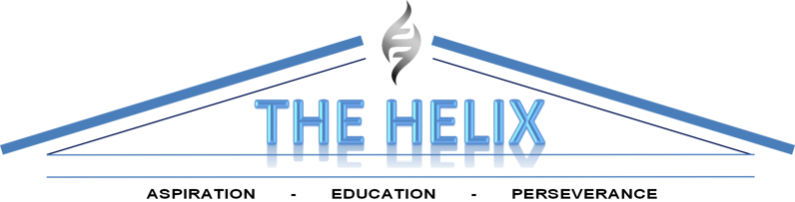

**EDUCATION CENTRE**

**ASPIRE - STUDY - PERSEVERE**



**Title: Admissions Arrangement’s Policy**

**Policy Coordinator: PK Maselino**

**Date Reviewed: 18th November 2024**

**Date Ratified: 18th November 2024**

**Status: Statutory**

**Delegation: Management Committee**

**Review Frequency Annually**

**Policy Review Date November 2025**

**Chair of Management Committee: Seeta Mepani**

**Head Teacher: PK Maselino**

**Introduction**

Section 19 of the Education Act 1996 provides that – each local education authority shall make arrangements for the provision of suitable education at school or otherwise than at school for those children of compulsory school age who, by reason of illness, exclusion from school or otherwise, may not for any period receive suitable education unless such arrangements are made for them.

------------------------------------

**The Helix Education Centre** provides three services of continuity of education at its PRU, Home Tuition and Tuition at its Hospital School to which Pupils are admitted. Five groups of pupils educated other than at (a mainstream) school (EOTAS) are catered for by THE HELIX EDUCATION CENTRE:

**Admission Process to the Secondary PRU**

**Excluded Pupils**

* The excluding school informs the Harrow Schools’ Admission Service (HSAS) of the permanent exclusion of the pupil.
* (As permanently excluded pupils in Harrow are currently the responsibility of the local authority from the 6th day of the exclusion) HSAS would send a referral to the Helix.
* The Helix would then send its Transition Support Officers (TSOs) to meet with the pupil and parents/carers to inform them about the Centres’, work and will arrange an induction at the centre. In some cases the TSOs might recommend that the pupil will be best placed either full or part time with one of our commissioned Alternative providers (APs).
* If the placement is to be at the Centre, the pupil then starts full time after one half day of induction. This is then followed by an initial academic, behavioural and attitudinal assessments.

For KS2, KS3, and KS4 pupils, the Centre endeavours to reintegrate them back to another local mainstream schools (apart from their previous one). The year 11 pupils remain on the the Helix school roll whilst attending either a mainstream Secondary school or an Alternative Provision.

* For pupils new to the Borough, Children Looked After (CLA) or new arrivals are first registered with the HSAS.
* HSAS will first seek a mainstream school placement for them unless it is known that the pupil is not suitable for placement at a mainstream school due to either the short period the pupil will be staying in Harrow or due to behavioural or Child Protection issues (actions as points 3 to 4 above are then carried out).

**Pupils with Statement of Special Educational Needs (SEN)**

Pupils with SENs who fall into the EOTAS category become so either as excluded pupils or as new arrivals to the borough. They become the responsibility of the local authority’s Special Educational Needs Assessment and Review Service (SENARS).

* SENARS will first try to place the pupil in a mainstream school or refer the pupil to The Helix Education Centre, if it is judged that the pupil need to undergo a period of assessment for a clearer identification of behavioural and academic needs before future placement to a specialist provision or mainstream school is made.
* The Centre would send its Transition Support Officers (TSOs) to meet with the pupil and parents/carers to inform them about the Centres’ work and will arrange an induction at the centre. In some cases the TSOs might recommend that the pupil will be best placed either full or part time with one of our commissioned Alternative providers (APs).
* If the placement is to be at the Helix Centre, the pupil then starts full time after an induction meeting and a half day of attendance; during which an initial academic, behavioural and attitudinal assessments are carried out.
* However, unlike the actions for Excluded Pupils, all statemented pupils remain the responsibility of SENARS to reintegrate back to another local mainstream school (apart from the pupil’s previous school).
* A small number of KS4 pupils remain at the Helix and are educated full-time or part time with APs making up the full time education equivalent to the end of their schooling.

**Admission to the Primary PRU**

As all the above.

**Summary**

* PEX Referral from Harrow Admissions to the Helix PRU.
* NB: the Helix PRU have found it continually problematic in admitting siblings to its KS3 & 4 classes when both siblings attend at the same time (as they become the focus for intimidation or joint assault on other pupils). The Helix has successfully managed admission of siblings at the same time only when one is in KS2 and the other in KS3 or KS4.